ハラールセティフィカエの監査サービス契約　F-2



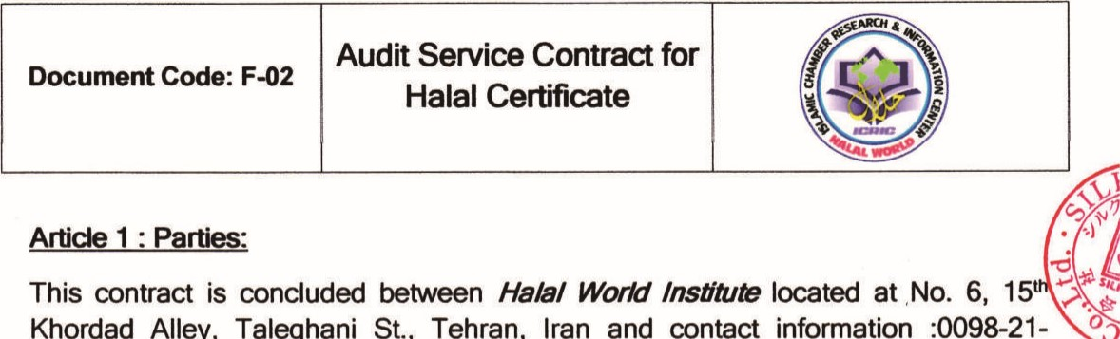

00

as applicant company for Halal Certification, herein after referred to as contracting parties.

# Article 2: Object of Contract

Auditing the products Iservices and company management system in accordance with the Halal requirements and OIC General Guidelines on Halal Food Standard and Islamic rules to assess the conformity of products/services with the above requirements, preparing the auditing report, issuing the Halal Certification, in case all requirements are met and are in conformity with General Guidelines of Halal Food approved by OIC in 2010 implementing two annually surveillance audits with auditing range of :

## Article 3: Auditing Place

Auditing place will be determined as follows: 1- Place No. 1:

2- Place No. 2:

Note 1: In case the places of auditing are changed, new auditing place should be notified to the certifying body in written, by a letter or express post.

Note 2: Applicant Company is obliged to inform the certifying body of any change or addition of new place within one month.

# rticle 4: Duration of the Contract

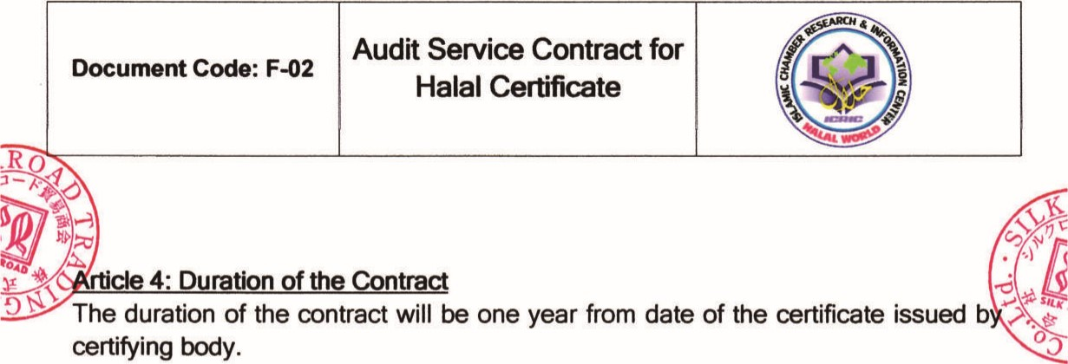

Mcle

5:

contract

costs

:



The duration of the contract will be one year from date of the certificate issued b

The cost for the first year audit certification will be as the following table:

|  |  |  |
| --- | --- | --- |
| No | Services | Cost (US$) |
| 5-1 | Prelimina Audit Process |  |
| 5-2 | First Sta e Audit |  |
| 5-3 | Second Stage Audit and Tests ( Issuing the Certificate |  |
| 54 | Total cost for certificate issuance |  |

The costs for surveillance audits and repeating audits will be as below:

|  |  |  |
| --- | --- | --- |
| No | Surveillance Audit] Repeating Audit | Cost (US$) |
| 5-5 | Foreve ear Audit |  |

Note: Value added tax will be added to the above article.

Article 6: Terms of Payment:

Terms of payment will be as below:

1. 1-25% of total costs for certification (Point 5-4) should be paid as downpayment after signing the contract.

6-2 60% of the total costs of certification ( Point 5-4)should be paid one week prior to the first stage auditing 

6-3-60% of total costs for certification (Point 5-4) should be paid after receiving the certificate.

Total costs for Surveillance Audit or Repeating Audit should be paid prior to



00

de 7: Legal Deductions

Any legal deductions in regard to the contract will be borne by the certifying body.

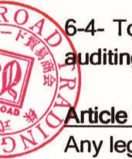

diting.

# Article 8: Certifying Body_ Obligations

8-1 to meet the agreed audit scheduled times for accomplishment of the services obliged in the contract,

8-2 To utilize expert and specialist auditor for the audit services,

8-3 To consider all documents related to audit procedures as confidential and not to disclose to anyone else.

8-4 To observe all intemal rules and regulations of the applicant company by her auditors and agents.

|  |  |  |
| --- | --- | --- |
| Document Code: F-02 | Audit Service Contract for Halal Certificate |  |

8-5 To carry out auditing, issue certificate and apply the most effective methods and common practices.

8-6 To provide and permit Halal World Institute logo to be stuck on the products or documents of the applicant company, in compliance with the certifying body rules for logo application.

8-7 To accomplish auditing process as below.

8-7-1 Preliminary Auditing Process (Optional)

* General evaluation and getting assured of all system functioning properly and their compliance with the basic standards and their proper implementation.
* Preparing a full report of the company status, its weaknesses and strengths and the opportunities for system improvement.

# 8-7-2 First Stage Auditing

* Evaluation of the scope of the activities of the applicant company.
* Assessment of all documentaries and their compliance with the basic standard.
* General identification of the organization and its procedures, and in case of necessity ,inspecting the whole sites
* Assessment of organization's readiness for auditing process
* Reporting the first stage audit observations

# 7-3 Second Stage Auditing

* planning for the auditing
* Implementing the audit in the place of applicant company
* Presenting the audit report
* Conducting follow-ups to be assured of discrepancies elimination
* In case of conformity with the Islamic rules and certificate issuance regulation, a Halal Certificate will be issued.
  1. probing the complaints on auditors or certifying body performance, in accordance with the regulations, in the relevant committee in order to respond the applicant.

|  |  |  |
| --- | --- | --- |
| Document Code: F-02 | Audit Service Contract for  Halal Certificate |  |

* 1. Observance of admitted audit principles such as: independence, indiscrimination, Justice, proof-based approach, non conflict of interests, auditor's authority and prohibiting of illegal intervene in auditing and testing, fair report, etc. 8-10 Observance of NACI (National Accreditation Center of Iran) regulation in relation with audit performance and certificate issuance.
  2. Access to the all documentary related to audit and decisions made for applicant certificate.
  3. Certifying body is authorized to provide all laboratory results and audit reports to accreditation body.

## Article 9: Applicant Company Obligations

9-1 Applicant company is bound to meet the requirements of this contract.

9-2 Applicant company shall introduce one of its managers as authorized representative for coordination of this contract issues.

9-3 Observance of all requirements for the product/service and system, complying with standard and audit scales or related by-laws and guidelines.

-4 To meet the requirements determined by certifying body about the application certificate, logo and limitation aroused by them.

5 To provide access to any information which is needed for, audit an rtification to certifying body.

9-6 To inform certifying body about any changes in the certified product]service. 9-7 To provide access to the product and working environment for performing the surveillance audit and supervision.

9-8 To pay all the costs according to the contract.

9-9 Applicant company should undertake not to claim about the product/service which is not certified as Halal.

9-10 Applicant company shall not misuse the certificate and logo in a way that causes discredit for certifying body.

9-11 Applicant company shall not use the certificate in the advertisement or logo on the product while the certificate has been suspended or invalidated.

|  |  |  |
| --- | --- | --- |
| Document Code: F-02 | Audit Service Contract for Halal Certificate |  |

9-12 Applicant company shall not use the audit reports or issued certificate in a wrong way.

9-13 If applicant company intends to prepare a copy or translation of the issued certificate, the context should be exactly the same with certificate.

9-14 To observe the requirements for application of certificate and logo in media. 9-15 To keep continuing its activity as similar to the time of audit and has been certified.

9-16 To apply the Halal logo just on the verified products, not the others.

9-17 To give back the invalidated or suspended certificate to the certifying body and not to misuse any copy of it.

9-18 To gather and preserve the records of complaints received from customers, consumer or Supervisory Governmental Administrations in regard with the quality and conformity with the standards and requirements and to provide those documentary to the certifying body upon her request.

These documentaries can include the followings:

* Full description of the discrepancy in the complaint and explaining the characteristics of the products in order to be detected in the market.
* The actions taken to remove the discrepancy and finding the cause of problem in raw materials, processes, production and measures to prev the repetition.

19 To inform certifying body of any alteration in the company which can effect o e product conformity with base standards and requirements, based on them certificate has been issued, such as :

* + Any alteration in the company structure, type of activity or its owners.
  + Any alteration in the chief or other decision making mangers which can effect on the conformity of product with the base standard and requirements.
  + Any alteration in the product ingredients
  + Any alteration in the methods and processes
  + Any movement of office or factory

|  |  |  |
| --- | --- | --- |
| Document Code: F-02 | Audit Service Contract for Halal Certificate |  |

* + Any alteration in the parameters based on the certificate has been issued.  Any other significant and impressive changes on the conformity with standard and requirements.

9-20 to meet the agreed audit scheduled times for accomplishment of his obligation according to the contract.

9-21 To provide and cover the costs needed for trip, accommodation, transportation of auditor. Evidently, if such costs are paid by certifying body, they will be accounted in the final invoice of applicant company.

9-22 Applicant company is obliged to pay off the amounts mentioned in the Article 5, at most 15 days after the invoice date.

9-23 Applicant company is obliged to pay off the amounts according to the invoice, paid for further testing and auditing caused by nonconformity or complaints received from legal organizations

9-24 Applicant company undertakes to provide the certifying body with the documents required by auditor.

## Article 10 : Damages and loss

10-1 certifying body and her staff are obliged to preserve the applicant company's roperties during the auditing process and if there is any damage caused by the ult of her staff, it should be rectified by the certifying body.

10-2 if the invalidation certificate and its copies have not been backed to certifying body, applicant company will be charged For every certification.

10-3 if the applicant company changes the scheduled time for audit, for any reason, 20% of total audit costs shall be paid by the company. If 48 hours before audit time, 50%, and if after the scheduled audit time, 100% shall be paid by the company.

10-4 after the certificate expiration or suspension, the applicant company is not authorized to apply Halal logo or certificate at any way. In the case, Applicant company shall pay compensation to certifying body.

### Article 11: Alteration and Modification

|  |  |  |
| --- | --- | --- |
| Document Code: F-02 | Audit Service Contract for Halal Certificate |  |

Any alterations or modifications in the contract shall be done according to the prior written authorization of each part.



04

### Article 12: Force Major



Any failure in accomplishment of each party's obligation, caused by unexpected natural events, will not void the contract and it will be enforced. Each party shall continue accomplishment of obligation after the hinder removal.

Article 13: Revoke of the contract By raising any following conditions, the contract will be revoked and any right to apply Halal logo will be dissolved.

13-1 Inobservance of certifying body and NACI regulations by the Applicant Company

13-2 Denial to fulfillment of surveillance audits by the Applicant Company

13-3 Rescission of Certificate due to the dissatisfactory results of surveillance audits

13-4 Inobservance of certifying body's and the applicant company's obligations

4-1 to insert the applicant company's information in Halal website

14-2 to provide a conformity letter to Applicant Company, if it is requested.

14-3 to issue a copy of Halal Certificate according to the contract's framework for free. May Applicant Company require more copies, he should pay per coy.

14-4 to amend the Halal Certificate for any reason, issuance of one substitute certificate will cost And for more copies, the costs shall be paid according to the clause 14-3 .

14-5 if any complain arises or any change occurs, the payable cost for per day audit will be

14-6 to provide consultation in Halal issue areas.

## Article 15: Legal Residence Place of Each Party

Legal residence place of each party is described in Article 1 and each party is bound to announce any change in the address to other party within one week in

written.

Certifying Body Appliænt Company