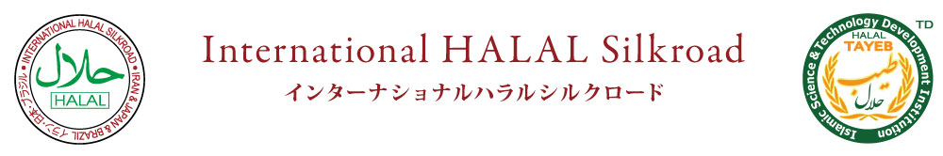
- www.silkroad-halal.com E-mail:ali-reza@sea.plala.or.jp

Inspection Report 検査報告
Ins ector Name: Do;Yahya Jahngiri | Date of Ins ection: Nov.
Com an Name: | Mana er Name:
Address:

Tel: + | Fax: +
Email : | Website:www.silkroadhalal.com
Previous Inspection Date: | Assessment from previous inspection or Major Findings :  Result: favorbale

Personnel

- Is there any non-Muslim staff? Yes No
(Please determine personnel names and their place of service in Appendix I ) list is attached
- Have staff passed necessary Islamic regulation training? Yes No
Please mention the courses?
- Do staff observe the regulation related to Halal and hygienic matters? [3 Yes Cl No
l- Product(s) Name:
2- Is there any Analysis Sheet/ Product Data Sheet? (If yes, please attach it) C] Yes , No 3- Type of Production Process: Manual , Machinery Mixed of both 4- Please determine the items in Appendix 2 which are applied as ingredients?
Please determine the items in Appendix 3 which are applied as additives?

Raw Material(s)

l- Raw Material Origin: ODomestic , Dlmport (Please determine the country of origin)
Religious regulations are observed in raw material? C] Yes C] No
Is there any kind of meat in the ingredient? Dyes No
Meat Supplying Origin: [Al)omestic , C]lmport (Please determine the originated country)
Religious regulations are observed in used meat? Yes C] No
Is there any prohibited oil in the ingredient? Yes NO
Additives are from Halal origin? [3 Yes No
Haram products are being produced in Halal production line? Yes D No

Legal Certifications or Permissions

ÜProduction License ÜNational Standard License DOther International Standards ÜHygienic License
00ther Mandatory License in your country

Packing Process , Storage and Distribution

Packing Type: [_l by Hand , C] Machinery Mixed of both
Have Hygienic and Religiousrules been observed while packing? [Z] Yes No
Storage Status:
[ANeat and not near Haram material OFilthy and contaminated with Haram material
Have Hygienic and Religious rules been observed while transportation? [Z Yes [3 No

Sampling

Product sample: Gelatin Powder Weight/Number/Value/Quantity: 300 Grams
Packing Type: Nylon Plastic
Laboratory Name: Gen Transfer Pioneer
The result of testing: Negative ( No haram found and gelatin is made of cow bones)
Date of result: Dec. 17,201.3

Final Result

Inspector Assessment and signature:
Halal Committee Assessment:

